



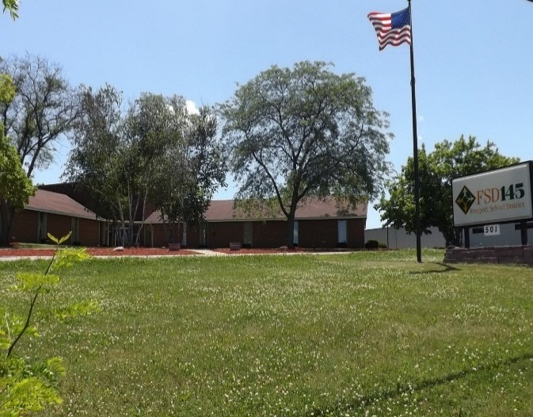

**www.fsd145.org**

501 E. South Street

Freeport, IL 61032

**Board of Education**

Janice Crutchfield,

President

George McCarty,

Vice - President

Jack Sosnowski

Pete Norman

Shirley Bradley

Martha Furst

Adron Simmons

**Superintendent**

Dr. Mike Schiffman

**Assistant Superintendent of Curriculum and instruction**

Dr. Duane Meighan

***Where are HAPP classes Located?***

The first through fourth grade HAPP classrooms are located at:

Center Elementary School 718 E. Illinois Freeport, IL 61032

The fifth and sixth grade HAPP classrooms are located at:

Carl Sandburg School 1717 W. Eby Freeport, IL 61032

**HAPP**

**High**

**Academic**

**Potential**

**Program**

**Patricia Schneider**

**Advanced Learning Coordinator**

**501 E. South Street**

**FREEPORT, IL 61032**

**PHONE: (815) 232-0300**

**Office: (815) 801-0503**

**pat.schneider@fsd145.org**

**www.fsd145.org/center**

In partnership with students, family and community, we educate every student for the challenges of today and the opportunities of tomorrow through the continuous pursuit of excellence.

***How do students qualify for HAPP?***

Students who might benefit from participating in HAPP classes are selected using state-approved identification criteria. All students in Kindergarten and Fourth Grade are given the Naglieri Non-verbal Ability Test. Students will be screened using the Naglieri test, Northwest Evaluation Association’s Measures of Academic Progress (NWEA MAP), and teacher recommendation. A variety of data is used to select students who demonstrate potential for success in the HAPP classes. Continued placement in HAPP is not guaranteed. The most significant criterion for continuation in non-identification years (Grades 1-3) is successful completion of the course of study for the previous year with high academic scores.

***Program Goals***

· Promote maximum achievement in basic skills and concepts

· Provide learning activities at an appropriate level and pace

· Promote integration of multiple disciplines into areas of study

· Develop skills in critical and creative thinking, decision making, and problem solving

· Encourage acquisition of the skills and attitudes necessary to become responsible, self-directed, lifetime learners

· Encourage students to develop high quality, creative products

· Provide students with the skills and motivation necessary to critically evaluate their own work

· Help students gain self-awareness and acceptance of their own capabilities, interests, needs and limitations

· Develop in students tolerance for the uniqueness of others, respect for the needs and rights of others, and recognition of the contributions of others

**What is HAPP?**

HAPP is the School District’s program for meeting the special needs of students who possess high academic potential. The program is more academically rigorous than the regular classroom.

HAPP includes self-contained classes that address all subjects in grades one through four. Self-contained classes and cluster groups address all subjects in grades five and six.